APPENDIX – E

DEPARTMENT OF PSYCHOLOGY
FACULTY OF EDUCATION & PSYCHOLOGY



BA Program
SYLLABUS 2023-24 ONWARDS

THE MAHARAJA SAYAJIRAO UNIVERSITY OF BARODA

Department of Psychology
Faculty of Education & Psychology, The Maharaja Sayajirao University of Baroda,
Lokmanya Tilak Road, Sayajigunj, Vadodara - 390002. Ph : +91 0265 2795019 E-mail : psychology.fep.msu@gmail.com ………………………………………………………...……………………………………………………………………

Structure and credit distribution of CBCS course in B. A. Honors Program

Course | Sem 1 | Sem 2 | Sem 3 | Sem 4 | Sem 5 | Sem 6 | Sem 7 | Sem 8 | Semester total
Major | 1 (4) | 3 (4) | 5 (4) | 8 (4) | 11 (4) | 14 (4) | 17 (4) | 20 (4) | 32
Major | 2 (4) | 4 (4) | 6 (4) | 9 (4) | 12 A, B. C.D,E (4) | 15 A, B. C.D, E (4) | 18 A, B. C.D, E (4) | 21 A, B. C.D, E (4) | 32
Major | - | - | 7 (4) | 10 (4) | 13 A, B, C, D,E (4) | 16 A, B, C, D, E (4) | 19 A, B, C, D, E (4) | 22 A, B, C, D, E (4) | 24
Minor | 1 (4) | 2 (4) | - | 3 (4) | 4 (4) | 6 (4) | 7 (4) | 8 (4) | 28
Minor | - | - | - | - | 5 (4) | - | - | - | 4
MDC | 1 (4) | 2 (4) | 3 (4) | - | - | - | - | - | 12
AEC | 1 (2) | 2 (2) | 3 (2) | 4 (2) | - | 5 (2) | - | - | 10
SEC | 1 (2) | 2 (2) | 3 (2) | 4 (2) | 5 (2) | - | - | - | 10
INTERN | - | - | - | - | - | 1 (4) | - | - | 4
VAC | 1 (2) | 2 (2) | 3 (2) | 4 (2) | - | - | - | - | 8
OJT | - | - | - | - | - | - | 1 (6) | 2 (6) | 12
Total | 22 | 22 | 22 | 22 | 22 | 22 | 22 | 22 | 176

Sr. | Course Type | Course Name | Credit
SEMESTER: 1
1 | Major :1 | Basic Psychological Processes - Fundamentals | 04
2 | Major: 2 | Basic Psychological Processes - Advanced | 04
3 | Minor :1 | Elementary Studies In Music, Dance And Drama | 04
4 | MDC :1 | Introduction to Mental Health | 04
5 | AEC:1 | English I - Foundation | 02
6 | SEC:1 | Life Skills Education | 02
7 | VAC :1 (IKS) | Indian Knowledge System and Psychology | 02
SEMESTER: 2
8 | Major :3 | Biological Basis of Behaviour | 04
9 | Major: 4 | Social Psychology | 04
10 | Minor :2 | Psychology And Arts | 04
11 | MDC: :2 | Media & Consumer Behaviour – Psychological Perspective | 04
12 | AEC:2 | Hindi - Foundation | 02
13 | SEC:2 | Positive Psychology | 02
14 | VAC :2 | Indian Psychology | 02
SEMESTER: 3
15 | Major :5 | Research Methodology |  | 04
16 | Major: 6 | Psychology of Personality |  | 04
17 | Major: 7 | Disciplines in Psychology |  | 04
18 | MDC : 3 | Influence of media on children and adolescents / OR  Family Dynamics (Department of Human Development & Family Studies) |  | 04
19 | AEC:3 | Enhancing Effective Language Skills in English (Department of English) / OR  Spoken Sanskrit -I (Department of Sanskrit) |  | 02
20 | SEC:3 | Statistical Skills I |  | 02
21 | VAC:3 (IKS) | Indian Psychology |  | 02
SEMESTER: 4
22 | Major :8 | Experimental Designs and Analysis |  | 04
23 | Major: 9 | Cognitive Psychology & Experiments I |  | 04
24 | Major: 10 | Developmental Psychology |  | 04
25 | Minor: 3 | Emotional Intelligence, Regulation and Competence / OR  Elements of Indian Philosophy I (Department of Philosophy) |  | 04
26 | AEC:4 | Mastering Effective Language Skills in English (Department of English) / OR  Spoken Sanskrit - II (Department of Sanskrit) |  | 02
27 | SEC:4 | Statistical Skills II |  | 02
28 | VAC :4 | Personal – Interpersonal - Gender – Social Sensitivity |  | 02

Sr. | BA | Sem | Course | E | Course Title | Department | Page
 | III | V | Core - 07 |  | Experimental Psychology – Theory | Psychology
 | III | V | Core - 08 |  | Research Methodology | Psychology
 | III | V | Core - 09 |  | Developmental Psychology | Psychology
 | III | V | Core - 10 |  | Experimental Psychology Practical I | Psychology
 | III | V | Core - 11 | a | Abnormal Psychology I | Psychology
 | III | V | Core - 11 | b | Basics of Industrial-Organisational Psychology | Psychology
 | III | V | Core - 11 | c | Counselling and Guidance : Concepts and Techniques | Psychology
 | III | V | Core - 11 | d | Educational Psychology I | Psychology
 | III | V | Core - 12 | a | Introduction to Diagnosis and Counselling Skills | Psychology
 | III | V | Core - 12 | b | Consumer Behaviour – Concepts, Processes and Applications | Psychology
 | III | V | Core - 12 | c | Exceptionality – Concepts and Assessment | Psychology
 | III | V | Core - 12 | d | Introduction to Children with Special Needs | Psychology
 | III | VI | Core – 13 |  | Experimental Design and Data Analysis | Psychology
 | III | VI | Core – 14 |  | Psychological Testing | Psychology
 | III | VI | Core – 15 |  | Psychology of Personality | Psychology
 | III | VI | Core – 16 |  | Experimental Psychology Practical II | Psychology
 | III | VI | Core – 17 | a | Abnormal Psychology II | Psychology
 | III | VI | Core – 17 | b | Application of Industrial-Organisational Psychology | Psychology
 | III | VI | Core – 17 | c | Processes of Counselling and Guidance | Psychology
 | III | VI | Core – 17 | d | Techniques in Education - PB | Psychology
 | III | VI | Core – 18 | a | Community Psychology – concepts and application | Psychology
 | III | VI | Core – 18 | b | Consumer Behavior – Groups, Culture, & Application | Psychology
 | III | VI | Core – 18 | c | Special education & Rehabilitation for exceptional individual | Psychology
 | III | VI | Core – 18 | d | Educational Guidance and Counselling | Psychology

SEMESTER III

 |  |  | Department of Psychology |  | Academic YEAR  2024-2025
 |  |  | Faculty of Education & Psychology, The Maharaja Sayajirao University of Baroda
 |  |  | Lokmanya Tilak Road, Sayajigunj, Vadodara - 390002. E-mail : psychology.fep.msu@gmail.com
Bachelor of Arts Honours: Psychology Graduate Program
YEAR |  | II | MAJOR 05 : RESEARCH METHODOLOGY | Credit |  |  | 4
Semester |  | III | MAJOR 05 : RESEARCH METHODOLOGY | Hours |  |  | 60
OBJECTIVES |  |  | To make the students understand meaning, nature and scope of research in psychology
 |  |  | To help the student understand and appreciate various types of research conducted in behavioral sciences
 |  |  | To help the students understand the different methods and techniques used in collection of data
 |  |  | To enable the student appreciate the importance of subjects chosen for the research and how to do it systematically
COURSE CONTENT
UNIT I |  | Meaning, Nature and Steps in Research |  |  |  | 15 hrs.
 |  | Meaning of research, nature and areas of behavioral research, phases and steps of research
 |  | Research problem: Nature and characteristics of research problem, difficulties in selecting and formulating the research problem, Nature of research hypotheses is, theoretical and operational definitions in research
 |  | Types of variables
UNIT II |  | Types of Research |  |  |  | 15 hrs.
 |  | Historical research
 |  | Descriptive research - field studies , ex -post facto studies, survey research, case study and ethnographic study, diagnostic studies
UNIT III |  | Tools of Data Collection |  |  |  | 15 hrs.
 |  | Quantitative methods : Rating Scales, Tests, Questionnaires, Inventories, Interview techniques, observation techniques, checklists, Qualitative methods
UNIT IV |  | Sampling Techniques |  |  |  | 15 hrs.
 |  | Probability sampling, non -probability sampling, quota sampling, simple random sampling, stratified random sampling, cluster sampling and others
REFERENCES
1. | Roesn, R. L., Rosenthal, R. (2002). Beginning Behavioural Research : A conceptual Primer. Fourth Edition. Pearson Education International, New Jersey
2. | McGuigan F. J. (1969) : Experimental Psychology. Prentice Hall of India Private Ltd., New Delhi
3. | Selltiz C, Jahoda M. & Cook S. W. (1961) : Research Methods in Social Relations. Holt, Rinchart and Winston, New York
4. | Underwood B. J. (1957) : Psychological Research. Appleton Century Crafts New York
5. | Singh A. K. (1987) : Tests, Measurement & Research Methods in Behavioral Sciences. Tata McGraw Hill, Bombay
6. | Best J. W & Kahn (1995) : Research in Education. 7th Edition, Prentice -Hall of India Pvt., New Delhi
7. | Shaugnessy (1990) : Research Methods in Psychology. Tata McGraw-Hill Publishing Co. Ltd., New Delhi.
8. | Chaudhary C. M. (1991) : Research Methodology. RBSA Publishers, S. M.S. Highway, Jaipur
9. | Ghosh, B. N. (1992) Scientific method and social Research. Sterling publishers Private Ltd.
10. | Krishnaswamy, O. R. (1993) Methodology of researches in Social Sciences. Himalaya Publishing House, Delhi

 |  |  | Department of Psychology |  | Academic YEAR  2024-2025
 |  |  | Faculty of Education & Psychology, The Maharaja Sayajirao University of Baroda
 |  |  | Lokmanya Tilak Road, Sayajigunj, Vadodara - 390002. E-mail : psychology.fep.msu@gmail.com
Bachelor of Arts Honours: Psychology Graduate Program
YEAR |  | II | MAJOR 06 : PSYCHOLOGY OF PERSONALITY | Credit |  |  | 4
Semester |  | III | MAJOR 06 : PSYCHOLOGY OF PERSONALITY | Hours |  |  | 60
OBJECTIVES |  |  | To enable the students to understand the concept of personality, various factors affecting personality
 |  |  | To make the students understand the processes of personality development
 |  |  | To help the students distinguish between normal and abnormal behaviour
COURSE CONTENT
UNIT I |  | INTRODUCTION TO PERSONALITY |  |  |  | 15 hrs.
 |  | The scientific study of personality
 |  | Methods: Ratings, Observations, Inventories and Projective tests
 |  | Normal and Abnormal Behaviour
UNIT II |  | development of personality |  |  |  | 15 hrs.
 |  | Basic principles
 |  | Emotional Foundations
 |  | Frustration, Stress and Conflict
UNIT III |  | description of personality |  |  |  | 15 hrs.
 |  | Personality style, Traits, The Self, Character
 |  | Attitudes, Values, and Defence Mechanisms
UNIT IV |  | dynamics and determinants |  |  |  | 15 hrs.
 |  | Biological approaches and psychoanalytical theories of motivation.
 |  | Biological, social and economic factors.
REFERENCES / BIBLIOGRAPHY
1. | Daftuar, C. & Sharma, R. (1997). Beyond Maslow- An Indian Perspective o Need Hierarchy. Journal of Indian Academy of Applied Psychology, 24(1), 1-8.
2. | Mangal, S. K. (2007). Abnormal Psychology. Sterling Publisher Pvt. Ltd. New Delhi.
3. | Nevid, J. S., Rathus, S. A., Greene, B. (1998). Abnormal Psychology in a changing world. Prentice Hall, New Jersey.
4. | Stagner, R. (1961). Psychology of Personality. McGraw Hill Book Company (Inc.), New York.
5. | Safaya, R. N. (1976). Personality: Indian Psychology. Munshiram Manoharlal Publisher Pvt. Ltd. NewYork.

 |  |  | Department of Psychology |  | Academic YEAR  2024-2025
 |  |  | Faculty of Education & Psychology, The Maharaja Sayajirao University of Baroda
 |  |  | Lokmanya Tilak Road, Sayajigunj, Vadodara - 390002. E-mail : psychology.fep.msu@gmail.com
Bachelor of Arts Honours: Psychology Graduate Program
YEAR |  | II | MAJOR 07: DISCIPLINES IN PSYCHOLOGY | Credit |  |  | 4
Semester |  | III | MAJOR 07: DISCIPLINES IN PSYCHOLOGY | Hours |  |  | 60
OBJECTIVES |  |  | To provide awareness to the students regarding few fields of psychology.
 |  |  | To help students understand the areas where psychologists can actively contribute
 |  |  | To explain to the students the importance of psychology as an applied discipline in the growth and sustenance of a healthy society
 |  |  | To enable students in making an active choice for selection of specialization courses to be offered at the third-year level in 5th and 6th semesters of their UG course.
COURSE CONTENT
UNIT I |  | ABNORMAL PSYCHOLOGY & CLINICAL PSYCHOLOGY |  |  |  | 15 hrs.
 |  | Definition, scope, methods, history, important concepts, profession and ethics of Abnormal Psychology and Clinical Psychology; Definition, scope, methods, history, important concepts, profession and ethics of related disciplines such as Community Psychology, Forensic Psychology, Criminal Psychology, and Neuropsychology
UNIT II |  | INDUSTRIAL & ORGANIZATIONAL PSYCHOLOGY AND CONSUMER BEHAVIOUR |  |  |  | 15 hrs.
 |  | Definition, scope, methods, history, important concepts, profession and ethics of Industrial Psychology, Organizational Psychology, Work Psychology, Human Resource Development, Consumer Behaviour; Definition, scope, methods, history, important concepts, profession and ethics of related disciplines such as Applied psychology, Business Psychology, Behavioral risk management, Occupational Psychology, Human resource management
UNIT III |  | COUNSELLING PSYCHOLOGY |  |  |  | 15 hrs.
 |  | Definition, scope, methods, history, important concepts, profession and ethics of Counselling Psychology.
 |  | SPORTS PSYCHOLOGY
 |  | Definition, scope, methods, history, important concepts, profession and ethics of Sports Psychology.
 |  | EXERCISE PSYCHOLOGY
 |  | Definition, scope, methods, history, important concepts, profession and ethics of Exercise Psychology.
UNIT IV |  | EDUCATIONAL PSYCHOLOGY |  |  |  | 15 hrs.
 |  | Definition, scope, methods, history, important concepts, profession and ethics of Educational Psychology.
 |  | SCHOOL PSYCHOLOGY
 |  | Definition, scope, methods, history, important concepts, profession and ethics of School Psychology.
 |  | HEALTH PSYCHOLOGY
 |  | Definition, scope, methods, history, important concepts, profession and ethics of Health Psychology.
REFERENCES / BIBLIOGRAPHY
1. | Carson, R. C., Butcher, J. N., Mineka, S. (2003). Abnormal Psychology And Modern Life (11th Edition). Delhi: Pearson Education Pvt. Ltd.
2. | Blum, M. L. & Naylor, C. (1984). Industrial Psychology - Its Theoretical and Social Foundations (1st Indian Edition). New Delhi: CBS Publishers
3. | Agrawal, R., & Rao, B.V.L.N. (2011). Education for Disabled Children. New Delhi: Shipra Publications
4. | Kochhar, S. K. (2006). Educational and Vocational Guidance in Secondary Schools. New Delhi : Sterling Publishers Private Limited
5. | Robbins, S. P. (2000). Organizational Behavior (9th Edition) Prentice Hall of India, New Delhi
6. | Paul M. Muchinsky (1998). Psychology Applied to work (6th Edition) Wordsworth Thomson Learning

 |  |  | Department of Psychology |  |  | Academic YEAR  2024-2025
 |  |  | Faculty of Education & Psychology, The Maharaja Sayajirao University of Baroda
 |  |  | Lokmanya Tilak Road, Sayajigunj, Vadodara - 390002. E-mail : psychology.fep.msu@gmail.com
Bachelor of Arts Honours: Psychology Graduate Program
YEAR |  | II |  | MDC 03 : INFLUENCE OF MEDIA ON CHILDREN AND ADOLESCENTS | Credit |  |  | 4
Semester |  | III |  | MDC 03 : INFLUENCE OF MEDIA ON CHILDREN AND ADOLESCENTS | Hours |  |  | 60
OBJECTIVES |  |  | To impart introductory understanding about the nature of media influence on children, adolescents and adult
 |  |  | To impart psychological understanding in investigating influence role of media genres
 |  |  | To enable students to critically appreciate the place and role of media in constructing our social worlds and reality
COURSE CONTENT
UNIT I |  | Young Children and Media |  |  |  |  | 15 hrs.
Understanding and identifying of Fantasy and Reality among children
Development of Script and Schema in Media Explanations
Children’s Socialisation Through Media
Imagination, Pretence, and Theory of Mind
UNIT II |  | Adolescence, Young Adult and Media |  |  |  |  | 15 hrs.
Media Use in Adolescence and Young Adult
The Role of Media Figures (celebrity, sports person & influencer) During Adolescence and young adult
Cultural Functions played by Media and it’s Uses
Media Influences on Body Image, Social representation and Mental Health
UNIT III |  | THE PSYCHOLOGY OF THE MEDIA AUDIENCE |  |  |  |  | 15 hrs.
The Psychology of the Media Audience
What Is Parasocial Interaction?
Fans and Fandom
The Viewer as Psychologist: Identification and
Parasocial Interaction
UNIT IV |  | GENRES and audience participation |  |  |  |  | 15 hrs.
Reality TV and Influencers
Sport and Celebrity
News and Current Affairs
REFERENCES / BIBLIOGRAPHY
1. | Giles, David. (2003). Media Psychology. New Jersey, Lawrence Earlbaum Associates, Inc.
2. | Luskin, B. J., & Friedland, L. (1998). Task force report: Media psychology and new technologies. Washington, DC: Division of Media Psychology, Division 46 of the American Psychological Association
3. | Döveling, Katrin. (2010). The Routledge Handbook of Emotions and Mass Media. Taylor and Francis
4. | Mcluhan, M., Gordon,W,T. (2003). Understanding media: the extensions of man. Gingko Press
5. | Comstock,G., & Scharrer, E.(2005). The Psychology of Media and Politics. California ; Elsevier Academic Press.
6. | Shrum, L. J. (2004). The Psychology of Entertainment Media. Mahwah;Lawrence Erlbaum Associates, Inc., Publishers

 |  |  | Department of Psychology |  |  | Academic YEAR  2024-2025
 |  |  | Faculty of Education & Psychology, The Maharaja Sayajirao University of Baroda
 |  |  | Lokmanya Tilak Road, Sayajigunj, Vadodara - 390002. E-mail : psychology.fep.msu@gmail.com
Bachelor of Arts Honours: Psychology Graduate Program
YEAR |  | II |  | MDC 03 : FAMILY DYNAMICS | Credit |  |  | 4
Semester |  | III |  | MDC 03 : FAMILY DYNAMICS | Hours |  |  | 60
OBJECTIVES |  |  | Familiarize oneself with family as a social institution, from a socio-psychological perspective
 |  |  | Develop awareness and basic insight into contemporary family with reference to changing structure, functions and sub-group variations (region, caste, class, etc.)
 |  |  | Develop sensitivity to the changing roles of family members with special focus on gender and life span
COURSE CONTENT
UNIT I |  | FAMILY AS A SOCIAL INSTITUTION |  |  |  |  | 15 hrs.
1.1 Change and Evolution: Stages and related theories
1.2 Definitions of the family, Structure of the family: The patriarchal and matriarchal family, joint, nuclear, or extended families. (Characteristics of each of these families), matrilocal, matrilineal,
patrilocal and patrilineal families.
1.3 Functions of the family, Family life stages. Family experience and personality development.
1.4 Influence of culture and family on personality.
1.5 Defense mechanisms in family situations.
UNIT II |  | UNDERSTANDING THE INDIAN FAMILY |  |  |  |  | 15 hrs.
2.1 Social Context Social factors influencing the family system (a brief overview).
2.2 Hindu philosophy, Caste & religion, social class, Patriarchal structure, Sanskritization and Modernization
2.3 Regional and Subcultural variations in Family life
2.4 An orientation, Urban family, Rural family, Tribal family Migrant families, displaced families
UNIT III |  | FAMILY AND INFLUENCING FACTORS |  |  |  |  | 15 hrs.
3.1 Determinants of roles, relationships: family size,
structure, age, gender and ordinal position, power
and hierarchy and patriarchy.
3.2 Family roles and individuals: A brief overview,
Role expectations and power relations across life stages
3.3 Gender issues and gender socialization. Being a women v/s Being a Man, Daughter/daughter-in-law, mother, Man, Husband, Father, Wife, in-law, aging women. Head of Family, Provider, Son, Brother, etc.
UNIT IV |  | WOMEN/WORK AND FAMILY LIFE |  |  |  |  | 15 hrs.
4.1 Status, image and roles Women in traditional society/family, Changing expectations and roles of women in contemporary family and their effects (positive and negative)
4.2 Personality and self-esteem, Familial status / roles and responsibilities, Physical and mental health
4.3 Problems faced, Tips for maintaining effective balance between roles; Redefining roles of other family members,
4.4 Rituals and the Family: Role of family rituals and their effects in maintaining family integrity
4.5 Media and Family, Portrayal of family in media, Influence of media on family
4.6 Attitudes and behavior (commercialism), Value system/norms, Family interaction patterns, Leisure time / recreation.
UNIT V |  | FAMILY STRESS / CRISIS AND COPING
5.1 Understanding of factors causing stress in everyday family life, physical, socio-cultural, environmental, etc,
5.2 Stress due to internal family factors: communication, abuse, violence, marital/parent child problems, etc.
5.3 Stresses due to external factors illness, unemployment, hospitalization, natural calamities, imprisonment striker and political crises and so on
5.4 Disruptions in family life due to stress: An overview. Management of stress and crises.
5.5 Understanding family strengths and its role in stress management. Seeking support from within and outside: Agencies offering support, family courts, family counseling center, child guidance clinics, family and marital therapy units
5.6The processes in interventions: A brief overview
5.5 Understanding family strengths and its role in stress management. Seeking support from within and outside: Agencies offering support, family courts, family counseling center, child guidance clinics, family and marital therapy units
REFERENCES / BIBLIOGRAPHY
1. | Giles, David. (2003). Media Psychology. New Jersey, Lawrence Earlbaum Associates, Inc.
2. | Luskin, B. J., & Friedland, L. (1998). Task force report: Media psychology and new technologies. Washington, DC: Division of Media Psychology, Division 46 of the American Psychological Association
3. | Döveling, Katrin. (2010). The Routledge Handbook of Emotions and Mass Media. Taylor and Francis
4. | Mcluhan, M., Gordon,W,T. (2003). Understanding media: the extensions of man. Gingko Press
5. | Comstock,G., & Scharrer, E.(2005). The Psychology of Media and Politics. California ; Elsevier Academic Press.
6. | Shrum, L. J. (2004). The Psychology of Entertainment Media. Mahwah;Lawrence Erlbaum Associates, Inc., Publishers

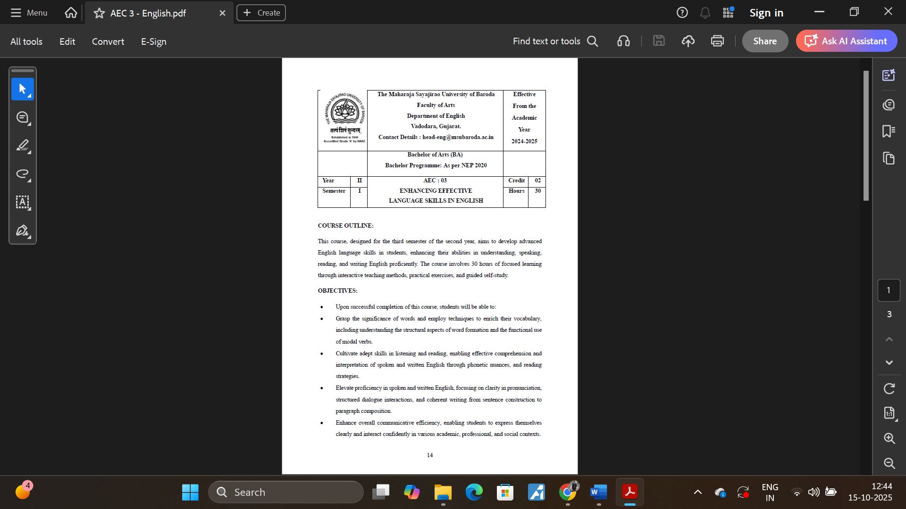

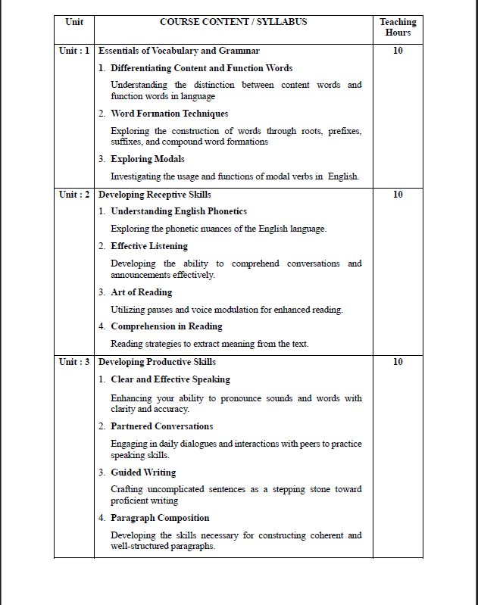

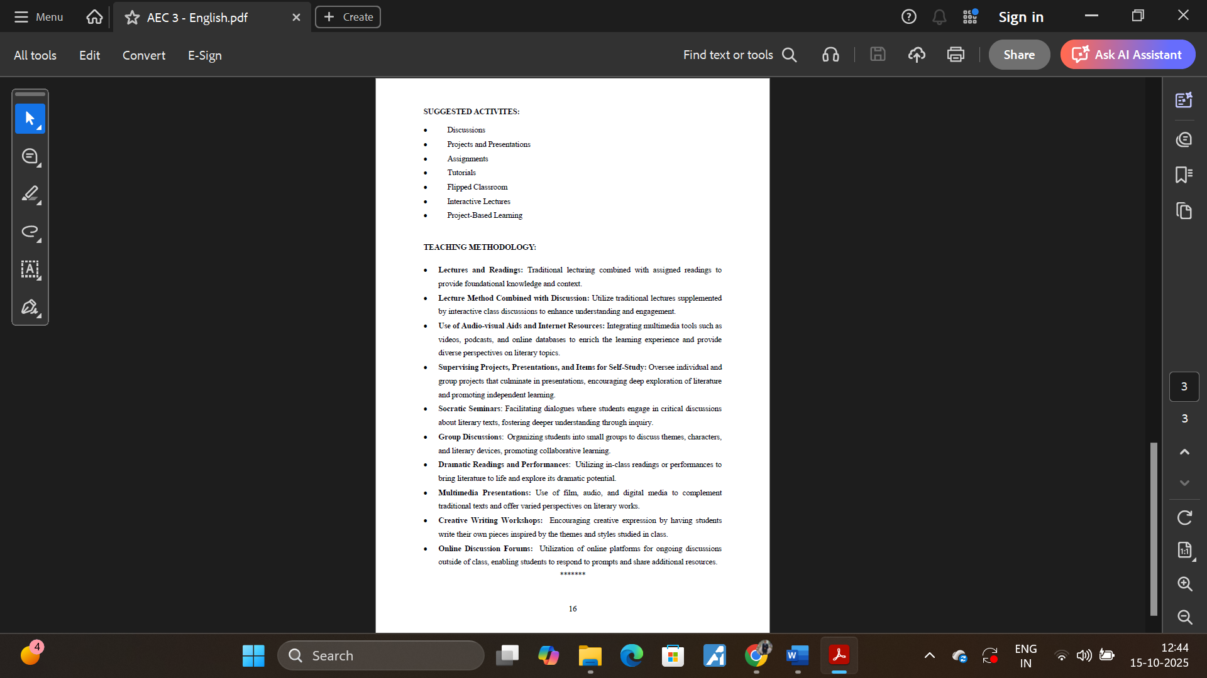

 | The Maharaja Sayajirao University of Baroda Faculty of Arts  Department of Sanskrit, Pali & Prakrit  E-mail: head-spp@msubaroda.ac.in |  | ACADEMIC YEAR  w.e.f. 2024-25
Bachelor of Arts HPP Psychology: NEP-2020
YEAR | II | AEC3  Spoken Sanskrit -I |  | CREDIT |  | 2
Semester FSBA-II | III |  |  | HOURS |  | 30
OBJECTIVES: | - This is an elementary course in Sanskrit Language designed for students who wish to learn Sanskrit from the very beginning.  - Essential Sanskrit grammar will be introduced through the multiple example methods with emphasis on students constructing/framing sentences themselves.  - This will enable the students to communicate in simple Sanskrit.
COURSE CONTENT / SYLLABUS
UNIT-I | Basic Sanskrit Grammar |  |  |  | 15 hrs.
UNIT-I | Nouns, Pronouns, Numbers, Verbs and Suffixes
UNIT-II | Grammar and Composition |  |  |  | 15 hrs.
UNIT-II | Adverbs, Indeclinables, Cases and Tenses
Modes of Transaction:
- Lectures-cum-discussion method supplemented with various appropriate audio-visual aids.
- Activity assignments (i.e. practical numerical problems)

 |  |  | Department of Psychology |  |  | Academic YEAR  2024-2025
 |  |  | Faculty of Education & Psychology, The Maharaja Sayajirao University of Baroda
 |  |  | Lokmanya Tilak Road, Sayajigunj, Vadodara - 390002. E-mail : psychology.fep.msu@gmail.com
Bachelor of Arts Honours: Psychology Graduate Program
YEAR |  | II |  | SEC 3 : STATISTICAL SKILLS I | Credit |  |  | 2
Semester |  | III |  | SEC 3 : STATISTICAL SKILLS I | Hours |  |  | 30
OBJECTIVES |  |  | To enable the students appreciate the use of statistics in behavioral science
 |  |  | To enable the students to understand the nature of data, types of data, categorize the data and read meaning into data
 |  |  | To help students interpret the data by use of central tendency and measures of variability
 |  |  | To help students understand the relationship among research variables by using
COURSE CONTENT
UNIT I |  | INTRODUCTION TO STATISTICS |  |  |  |  | 15 hrs.
Importance of measurement; Difference between measurement and evaluation; Meaning, nature and functions of statistics.
Universe, population, sample. Sampling processes. Parameters and statistics, parametric and nonparametric statistics and their application. Descriptive and inferential statistics.
 |  | INTRODUCTION TO JASP
 |  | Using The JASP Environment; Data Handling In JASP; Data Editing In JASP; JASP Analysis Menu; Descriptive Statistics; Splitting Data Files; Descriptive Data Visualisation; Basic Plots; Customisable Plots; Editing Plots; Exploring Data Integrity; Data Transformation; Effect Size
UNIT II |  | FREQUENCY DISTRIBUTION, GRAPHIC REPRESENTATION
 |  | Meaning of Data, Tabulation of Data, making a frequency distribution table, meaning of a score, frequency polygon, and histogram frequency and percentage analysis
 |  | MEASURES CENTRAL TENDENCY AND VARIABILITY |  |  |  |  | 15 hrs.
Measures of central tendency - mean, median, mode
Measures of variability - range, average deviation, quartile deviation, standard deviation
Concept of standard error. The meaning and importance of standard deviation, and standard error . How all these concepts are used in understanding data.
REFERENCES / BIBLIOGRAPHY
1. | Garrett H. E. (1966). Statistics in Psychology & Education. Allied Pacific Private Limited, Mumbai.
2. | Mohanty B., Misra S. (2016). Statistics for behavioural and social sciences. Sage Publications, New Delhi.
3. | Goss-Sampson, M. A. (2024). Statistical Analysis in JASP 0.18.3: A Guide for Students. March 2024.

 |  |  | Department of Psychology |  |  | Academic YEAR  2024-2025
 |  |  | Faculty of Education & Psychology, The Maharaja Sayajirao University of Baroda
 |  |  | Lokmanya Tilak Road, Sayajigunj, Vadodara - 390002. E-mail : psychology.fep.msu@gmail.com
Bachelor of Arts Honours: Psychology Graduate Program
YEAR |  | II |  | VAC 3 : INDIAN PSYCHOLOGY | Credit |  |  | 2
Semester |  | III |  | VAC 3 : INDIAN PSYCHOLOGY | Hours |  |  | 30
OBJECTIVES |  |  | The Indian knowledge system and the contributions of great scholars.
 |  |  | To provide a roadmap for systematic study and research of various disciplines of IKS.
 |  |  | To understand authentic sources—such as source texts, historical accounts, inscriptions and other records, material and other evidence, and also rigorous sociological records of current practices of different communities.
 |  |  | To understand objectives, methodology and core concepts of the Indian Knowledge Traditions and distinguish them from other Knowledge Traditions of the world.
COURSE CONTENT
UNIT I |  | medieval indian psychology |  |  |  |  | 15 hrs.
- Early medieval period
- Late medieval period
- Medieval period of Gujarat
UNIT II |  | modern indian psychology and psychofuturology |  |  |  |  | 15 hrs.
- Early modern period
- Late modern period
- Independence and partition
- Contemporary
- Future studies in Psychology
- Modern, contemporary and future studies of Gujarat
REFERENCES / BIBLIOGRAPHY
1. | Baladev Upadhyaya, Samskrta Śāstrom ka Itihās, Chowkhambha, Varanasi, 2010.
2. | D. M. Bose, S. N. Sen and B. V. Subbarayappa, Eds., A Concise History of Science in India, 2nd Ed., Universities Press, Hyderabad, 2010.
3. | Astāngahrdaya, Vol. I, Sūtrasthāna and Śarīrasthāna, Translated by K. R. Srikantha Murthy, Vol. I, Krishnadas Academy, Varanasi, 1991.
4. | Dharampal, Some Aspects of Earlier Indian Society and Polity and Their Relevance Today, New Quest Publications, Pune, 1987.
5. | Dharampal, Indian Science and Technology in the Eighteenth Century: Some Contemporary European Accounts, Dharampal Classics Series, Rashtrotthana Sahitya, Bengaluru, 2021.
6. | Dharampal, The Beautiful Tree: Indian Indigenous Education in the Eighteenth Century, Dharampal Classics Series, Rashtrotthana Sahitya, Bengaluru, 2021.
7. | J. K. Bajaj and M. D. Srinivas, Indian Economy and Polity in Eighteenth century Chengalpattu, in J. K. Bajaj ed., Indian Economy and Polity, Centre for Policy Studies, Chennai, 1995, pp. 63-84.
8. | J. K. Bajaj and M. D. Srinivas, Annam Bahu Kurvita Recollecting the Indian Discipline of Growing and Sharing Food in Plenty, Centre for Policy Studies, Chennai, 1996.
9. | J. K. Bajaj and M. D. Srinivas, Timeless India Resurgent India, Centre for Policy Studies, Chennai, 2001.
10. | M. D. Srinivas, The methodology of Indian sciences as expounded in the disciplines of Nyāya, Vyākarana, Ganita and Jyotisa, in K. Gopinath and Shailaja D. Sharma (eds.),
11. | An Introduction to Indian Knowledge Systems: Concepts and Applications, B Mahadevan, V R Bhat, and Nagendra Pavana R N; 2022 (Prentice Hall of India).
12 | Indian Knowledge Systems: Vol I and II, Kapil Kapoor and A K Singh; 2005 (D.K. Print World Ltd).
13 | The Wonder That Was India, Arthur Llewellyn Basham, 1954, Sidgwick& Jackson.
14 | The India they saw series (foreigner visitors on India in history from 5CE to 17th century), Ed. Meenakshi Jain and Sandhya Jain, Prabhat Prakashan

SEMESTER IV

 |  |  | Department of Psychology |  | Academic YEAR  2024-2025
 |  |  | Faculty of Education & Psychology, The Maharaja Sayajirao University of Baroda
 |  |  | Lokmanya Tilak Road, Sayajigunj, Vadodara - 390002. E-mail : psychology.fep.msu@gmail.com
Bachelor of Arts Honours: Psychology Graduate Program
YEAR |  | II | MAJOR 08 : EXPERIMENTAL DESIGN AND DATA ANALYSIS | Credit |  |  | 4
Semester |  | III | MAJOR 08 : EXPERIMENTAL DESIGN AND DATA ANALYSIS | Hours |  |  | 60
OBJECTIVES |  |  | To help the students plan the basic blue print of research by using different research designs
 |  |  | To expose students to experimental research, experimental control and how to use the control in designing experimental research
 |  |  | To help the students understand the importance of psychological factors and parameters for explaining different psychological phenomena by exposing them to the basics of analysis
COURSE CONTENT
UNIT I |  | TYPES OF RESEARCH |  |  |  | 15 hrs.
 |  | Fundamental concepts of quantitative and qualitative research, Methods of qualitative research
 |  | Comparison between qualitative and quantitative research, content analysis, narrative analysis and use of corroborative evidences , like verbatims, photos etc
Some specific methods of research specifically applied in different sub disciplines
Clinical case study method, organizational case study method, case writing,Llongitudinal research, Cohot studies, Action research
UNIT II |  | CONCEPT OF RESEACH DESIGN & TECHNIQUES OF CONTROL |  |  |  | 15 hrs.
 |  | Meaning and purpose of research designs, Criteria for research designs, Basic principles of experimental design , matched group design, single group design, repeated measure design,quasi experimental design
 |  | Extraneous variables : techniques of elimination, constancy of condition, balancing, counterbalancing, randomization; Experimental variables : moderator and mediator effects; Experimental control : placebo control and zero control; Control of subject related artifacts : demand characteristics, evaluation apprehension, good subjects; Control of experimenter expectancy : Double-blind procedure, and expectancy control design
UNIT III |  | Analysis of Variance |  |  |  | 15 hrs.
- One-way ANOVA,
- Two-Way ANOVA,
- ANCOVA
- The application of these analysis with appropriate research designs.
UNIT IV |  | Correlation and regression analysis |  |  |  | 15 hrs.
- Correlations
- Simple Regression
- Multiple Regression
REFERENCES / BIBLIOGRAPHY
1. | Roesn, R. L., Rosenthal, R. (2002). Beginning Behavioural Research : A conceptual Primer. Fourth Edition. Pearson Education International, New Jersey
2. | McGuigan F. J. (1969) : Experimental Psychology. Prentice Hall of India Private Ltd.
3. | Singh A. K. (1987): Tests, Measurement & Research Methods in Behavioral Sciences. Tata McGraw Hill, Bombay

 |  |  | Department of Psychology |  |  | Academic YEAR  2024-2025
 |  |  | Faculty of Education & Psychology, The Maharaja Sayajirao University of Baroda
 |  |  | Lokmanya Tilak Road, Sayajigunj, Vadodara - 390002. E-mail : psychology.fep.msu@gmail.com
Bachelor of Arts Honours: Psychology Graduate Program
YEAR |  | II |  | MAJOR 09 : COGNITIVE PSYCHOLOGY AND EXPERIMENTS I | Credit |  |  | 4
Semester |  | III |  | MAJOR 09 : COGNITIVE PSYCHOLOGY AND EXPERIMENTS I | Hours |  |  | 60
OBJECTIVES |  |  | To create interest and excitement towards psychological phenomena
 |  |  | To develop an awareness of psychological tools and technique
 |  |  | To provide basic training in planning and conducting experiments
COURSE CONTENT
UNIT I |  | PSYCHOPY : bASICS |  |  |  |  | 15 hrs.
Introduction
Building your first experiment
Using images: a study into face perception
Timing and brief stimuli: Posner cueing
Creating dynamic stimuli (revealing text and moving stimuli)
Providing feedback: simple Code Components
UNIT II |  | PSYCHOPY : aDVANCED |  |  |  |  | 18 hrs.
Ratings: measure the ‘Big 5’ personality constructs
Randomization, blocks and counterbalancing: a bilingual Stroop task
Using the mouse for input: creating a visual search task
 |  | REACTION TIME
 |  | Reaction Time and Association: Reaction Time, Judgment Time, Latency. The determinants of Reaction Time, Association Experiments
UNIT III |  | VISUAL PERCEPTION |  |  |  |  | 15 hrs.
 |  | Perception of distance, perception of size, perception of form, perception of movement - physical and perceived movement, perception of colour, perception of space, concept of constancy
UNIT IV |  | VISUAL COGNITION |  |  |  |  | 16 hrs.
 |  | Visual object perception, Visual scene perception, visual attention, visual aesthetics
REFERENCES / BIBLIOGRAPHY
1. | Collins M. and Drever J. (1949) : Experimental Psychology. Matheun & Co. Ltd., London
2. | D’Amato M. R. (1976) : Experimental Psychology : Methodology Psychophysics and Learning. New York - Tokyo, McGraw Hill Kogakusha
3. | Postman L. and Egan J. (1949) : Experimental Psychology. Harper & Row (Kalyani Pub. Ludhiana)
4. | Underwood B. J. (1949) : Experimental Psychology - An Introduction. New York : Appleton Country Crofts Indian Reprint. The Finances of India Press – 1965
5. | Woodworth R. S. & Schosberg H. (1938) : Experimental Psychology. New York (Holt ) Rinehart and Winston Inc. Third Indian Reprint Oxford IBH Publishing Co. New Delhi, Bombay, Calcutta
6. | Snodgrass and Haydon (1998). Human Experimental Psychology
7. | Anderson John R. (1980). Cognitive Psychology : and its implications. IInd edition, W. H. Freeman and Company, New York

 |  |  | Department of Psychology |  |  | Academic YEAR  2024-2025
 |  |  | Faculty of Education & Psychology, The Maharaja Sayajirao University of Baroda
 |  |  | Lokmanya Tilak Road, Sayajigunj, Vadodara - 390002. E-mail : psychology.fep.msu@gmail.com
Bachelor of Arts Honours: Psychology Graduate Program
YEAR |  | II |  | MAJOR 10 : DEVELOPMENTAL PSYCHOLOGY | Credit |  |  | 4
Semester |  | III |  | MAJOR 10 : DEVELOPMENTAL PSYCHOLOGY | Hours |  |  | 60
OBJECTIVES |  |  | To expose the students to the concept of development , different types of development
 |  |  | To help students understand the different factors and determinants affecting the process of development
 |  |  | To help students understand the developmental stages in the life span and the differential nature of developmental processes across different life stages
COURSE CONTENT
UNIT I |  | CONCEPT OF DEVELOPMENT , DETERMINANTS AND THEORIES |  |  |  |  | 11 hrs.
 |  | Concept of Development, growth, Maturation and Evolution; Development from a social-historical perspective; Themes in study of human development; Theories of Development; Determinants of Development; Research methods in developmental psychology; Scope of Developmental psychology
UNIT II |  | DEVELOPMENT IN PRENATAL, NEONATAL, INFANCY EARLY CHILDHOOD |  |  |  |  | 11 hrs.
 |  | Hereditary influences on development; Behavioral genetics – contributions and criticism; Prenatal Growth and Development; Development and Birth Complications; Cultural and historical variations in birthing practice; The World of the New Born; Physical, Sensori-motor development, Cognitive, Social and Language Development; Emotional development, temperament and attachment; Development of self-concept
UNIT III |  | SCHOOL-AGE CHILDHOOD AND ADOLESCENCE |  |  |  |  | 11 hrs.
 |  | Cognitive Advances in Thinking
 |  | Expanding Social Interactions : Peer Influence
 |  | Moral Development – affective, cognitive and behavioral components; Aggression and altruism
 |  | Physical and Sexual Maturation; Social impact of pubertal changes; Body image concern
 |  | Identity and Experience; Origin and development of self-esteem; Case of minority youth
 |  | Sex difference and gender role development; Developmental trends in gender typing
UNIT IV |  | ADULTHOOD AND AGING |  |  |  |  | 12 hrs.
 |  | Early Adulthood: Marriage, Alternatives to Marriage, Social Life and Change; Work and Leisure
 |  | Experiencing Middle Age: New Developmental Tasks , Marriage and Family life, Identity and Interpersonal behavior, Physical changes
 |  | Later adulthood and Aging: The Personal Context of Later life; Social aspects of later life; Dying and Bereavement
REFERENCES / BIBLIOGRAPHY
1. | Papalia, D. E. (1998). Human Development. 7th Edition. Tata McGraw Hill Publishing
2. | Kail, R.V & Cavanaugh, J. C. (2000). Human Development : A Lifespan View. Second Edition
3. | Schell, R. E. & Hall, E. (1979). Developmental psychology Today. Random House Inc.
4. | Shaffer, D. R. & Kipp, K. (2007). Developmental Psychology – Childhood and Adolescence. 7th Edition, Thomson Wadsworth.

 |  |  | Department of Psychology |  |  | Academic YEAR  2024-2025
 |  |  | Faculty of Education & Psychology, The Maharaja Sayajirao University of Baroda
 |  |  | Lokmanya Tilak Road, Sayajigunj, Vadodara - 390002. E-mail : psychology.fep.msu@gmail.com
Bachelor of Arts Honours: Psychology Graduate Program
YEAR |  | II |  | MINOR 03 : EMOTIONAL INTELLIGENCE, REGULATION AND COMPETENCE | Credit |  |  | 4
Semester |  | III |  | MINOR 03 : EMOTIONAL INTELLIGENCE, REGULATION AND COMPETENCE | Hours |  |  | 60
OBJECTIVES |  |  | To expose the students to the concept of emotion and emotion intelligence
 |  |  | To help students understand the emotional regulation
 |  |  | To help students develop competence in emotion and emotion regulation
COURSE CONTENT
UNIT I |  | EMOTIONS, FEELINGS AND MOODS |  |  |  |  | 11 hrs.
 |  | Definition and different types of emotions
UNIT II |  | EMOTIONAL INTELLIGENCE |  |  |  |  | 11 hrs.
 |  | Concepts of emotional intelligence, theories of emotional intelligence and assessment of emotional intelligence
UNIT III |  | EMOTION REGULATION |  |  |  |  | 11 hrs.
 |  | What is emotional regulation, theories of emotion regulation, techniques of emotion regulation
UNIT IV |  | EMOTIONAL COMPETENCE |  |  |  |  | 12 hrs.
 |  | Emotion regulation strategies, emotional competence strategies
REFERENCES / BIBLIOGRAPHY
1. | The Handbook of Emotional Intelligence: The Theory and Practice of Development, Evaluation, Education, and Application--at Home, School, and in the Workplace, By Reuven Bar-On, James D. A. Parker · 2000
2. | Harvard Business Review Emotional Intelligence Collection (4 Books) (HBR Emotional Intelligence Series), By Harvard Business Review, Daniel Goleman, Ellen Langer, Christina Congleton, Annie McKee · 2017
3. | Emotional Intelligence in Everyday Life, John D. Mayer, Joseph Ciarrochi, Joseph P. Forgas, 2013
4. | Emotional Intelligence - Theoretical and Cultural Perspectives. By Robert J. Emmerling, Vinod K. Shanwal, Manas K. Mandal · 2008
5. | Emotional Intelligence: Why It Can Matter More Than IQ By Daniel Goleman · 2006
6. | Emotional Intelligence Encyclopedia By Mi$ter X · 2020
7. | Affect Regulation Training: A Practitioners' Manual By Matthias Berking, Brian Whitley · 2010
8. | Handbook of Emotion Regulation, Brett Q. Ford, James J. Gross, 2024
9. | Emotional Competence: The Fountain of Personal, Professional and Private Success, By Dagmar Rudel-Steinbauer · 2017
10. | Schools of Social-Emotional Competence and Character: Actions for School Leaders, Teachers, and Support Staff By Maurice Elias, Marvin Berkowitz · 2015
11. | The Development of Emotional Competence By Carolyn Saarni · 1999
12. | Emotional Competence: The Secret to Getting More Out of Life! By Eveline Lonoce · 2018

 |  |  | Department of Psychology |  | Academic YEAR  2024-2025
 |  |  | Faculty of Education & Psychology, The Maharaja Sayajirao University of Baroda
 |  |  | Lokmanya Tilak Road, Sayajigunj, Vadodara - 390002. E-mail : psychology.fep.msu@gmail.com
Bachelor of Arts Honours: Psychology Graduate Program
YEAR |  | II | MINOR 03 : ELEMENTS OF INDIAN PHILOSOPHY - I | Credit |  |  | 4
Semester |  | III | MINOR 03 : ELEMENTS OF INDIAN PHILOSOPHY - I | Hours |  |  | 60
OBJECTIVES |  |  | To enable the students to understand the concepts of Indian philosophy.
COURSE CONTENT
UNIT I |  | Introduction |  |  |  | 15 hrs.
 |  | Nature and scope of Indian Philosophy, its common characteristics
UNIT II |  | Materialism and Spiritualism |  |  |  | 15 hrs.
 |  | Charvaka materialism - Ethics, ontology, epistemology, Bhagvad Gita- the doctrine of knowledge, action and devotion.
UNIT III |  | Jainism |  |  |  | 15 hrs.
 |  | Theory of reality, theory of relativity of knowledge, karma, bondage, liberation, Jaina ethics of ahimsa
UNIT IV |  | Buddhism |  |  |  | 15 hrs.
 |  | Four noble truths, eight-fold path, theory of causation (Pratityasamutpada), theory of momentariness (Kshanabhangavada), Hinayana and Mahayana Buddhism
REFERENCES / BIBLIOGRAPHY
1. | Sharma,C.D, 1983, A Critical Survey of Indian Philosophy, Delhi, Motilal Banarsidas
2. | Dutta and Chatterjee, 1948, Introduction to Indian Philosophy, Calcutta, University of Calcutta.
3. | Radhakrishnan,S, 1929, Indian Philosophy vol.1 & 2, George Allen & Unwin Ltd.
4. | Hiriyana, M,1973, Essentials of Indian Philosophy, Delhi, George Allen & Unwin Pvt. Ltd

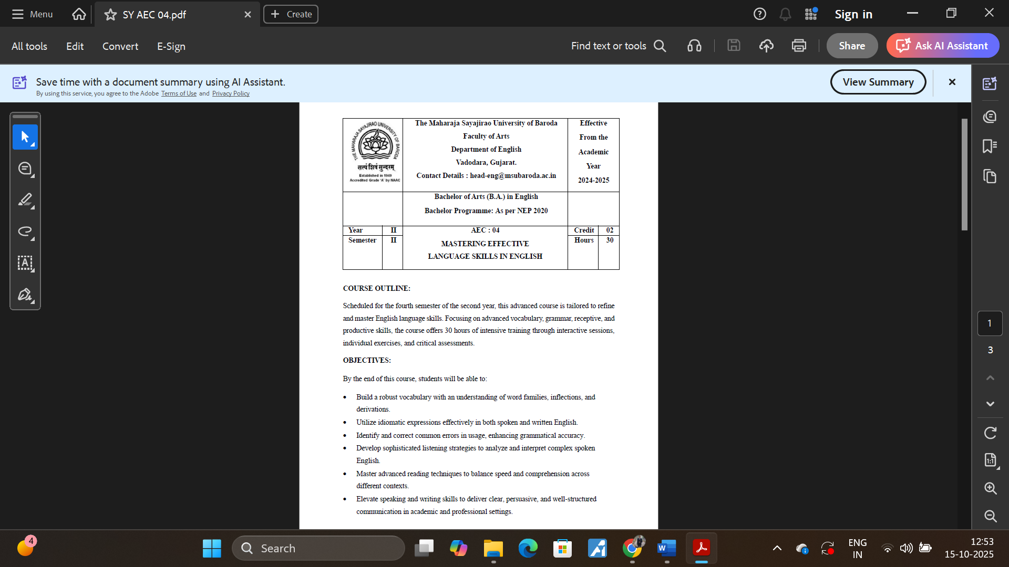

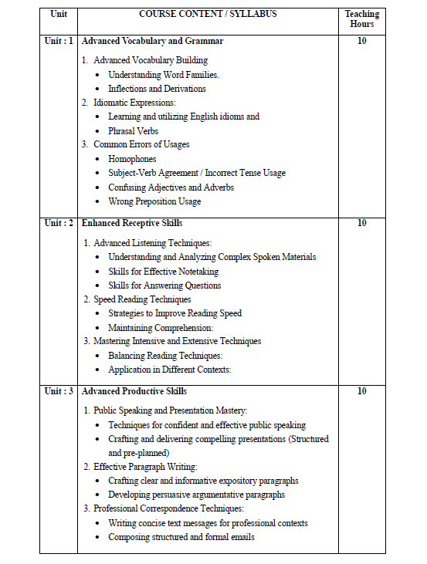

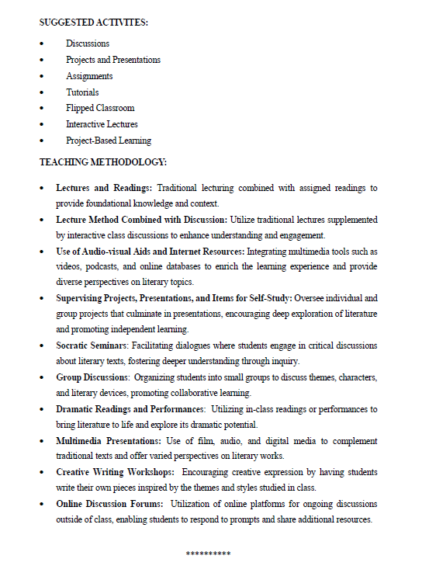

 | The Maharaja Sayajirao University of Baroda Faculty of Arts  Department of Sanskrit, Pali & Prakrit  E-mail: head-spp@msubaroda.ac.in |  | ACADEMIC YEAR  w.e.f. 2024-25
Bachelor of Arts HPP Psychology: NEP-2020
YEAR | II | AEC4  Spoken Sanskrit -II |  | CREDIT |  | 2
Semester FSBA-II | IV |  |  | HOURS |  | 30
OBJECTIVES: | - This is an elementary course in Sanskrit Language designed for students who wish to learn Sanskrit from the very beginning.  - Essential Sanskrit grammar will be introduced through the multiple example methods with emphasis on students constructing/framing sentences themselves.  - This will enable the students to communicate in simple Sanskrit.  - This course is equivalent to the Certificate Course in Communicative Sanskrit Level 1 conducted under the Center for Spoken Sanskrit of the Department of Sanskrit, Pali & Prakrit, Faculty of Arts, The Maharaja Sayajirao University of Baroda. After passing this exam, Students become eligible to seek admission to the Certificate Course in Communicative Sanskrit -Level 2 of the Center for Spoken Sanskrit.
COURSE CONTENT / SYLLABUS
UNIT-I | Basic Sanskrit Grammar |  |  |  | 15 hrs.
UNIT-I | Sandhi and Samasa with its varieties, Kartari, Karmani and Bhave sentence constructions
UNIT-II | Grammar and Composition |  |  |  | 15 hrs.
UNIT-II | Krdantas, storytelling and letter writing
Modes of Transaction:
- Lectures-cum-discussion method supplemented with various appropriate audio-visual aids.
- Activity assignments (i.e. practical numerical problems)

 |  |  | Department of Psychology |  |  | Academic YEAR  2024-2025
 |  |  | Faculty of Education & Psychology, The Maharaja Sayajirao University of Baroda
 |  |  | Lokmanya Tilak Road, Sayajigunj, Vadodara - 390002. E-mail : psychology.fep.msu@gmail.com
Bachelor of Arts Honours: Psychology Graduate Program
YEAR |  | II |  | SEC 04 : STATISTICAL SKILLS II | Credit |  |  | 2
Semester |  | IV |  | SEC 04 : STATISTICAL SKILLS II | Hours |  |  | 30
OBJECTIVES |  |  | To enable the students appreciate the use of statistics in behavioral science
 |  |  | To enable the students to understand the nature of data, types of data, categorize the data and read meaning into data
 |  |  | To help students interpret the data by use of central tendency and measures of variability
 |  |  | To help students understand the relationship among research variables by using
COURSE CONTENT
UNIT I |  | PROBABILITY |  |  |  |  | 15 hrs.
 |  | Probability, normal probability curve, principles and applications of probability, skewness and kurtosis how to determine a normal and a non-normal distribution. properties of normal probability curve. Levels of significance, Regions of rejection.
UNIT II |  | TESTING THE DIFFERENCE |  |  |  |  | 15 hrs.
 |  | Level of significance. Type of hypotheses. Type I and type II errors. Testing of difference between means, t test for correlated, and uncorrelated sample for large and small groups. The X² test for two categories with two or more number of categories.
REFERENCES / BIBLIOGRAPHY
1. | Garrett H. E. (1966). Statistics in Psychology & Education. Allied Pacific Private Limited, Mumbai.
2. | Mohanty B., Misra S. (2016). Statistics for behavioural and social sciences. Sage Publications, New Delhi.

 |  |  | Department of Psychology |  |  | Academic YEAR  2024-2025
 |  |  | Faculty of Education & Psychology, The Maharaja Sayajirao University of Baroda
 |  |  | Lokmanya Tilak Road, Sayajigunj, Vadodara - 390002. E-mail : psychology.fep.msu@gmail.com
Bachelor of Arts Honours: Psychology Graduate Program
YEAR |  | II |  | VAC 04 : PERSONAL – INTERPERSONAL - GENDER – SOCIAL SENSITIVITY | Credit |  |  | 2
Semester |  | IV |  |  | Hours |  |  | 30
OBJECTIVES |  |  | To improve participants' awareness of their actions and emotions associated with them.
 |  |  | Development of the participants' motivation to succeed in inter-personal discussions.
 |  |  | To promote participants' clarity of their core values and priorities.
 |  |  | Promoting an individual's ability to deal with and accept emotions of theirs and others.
 |  |  | To develop principles and a framework for connecting individuals' core beliefs and priorities with their behavior.
 |  |  | Encouraging members to experience and learn from their emotions.
COURSE CONTENT
UNIT I |  | SENSITIVITY & INTERPERSONAL SENSITIVITY |  |  |  |  | 11 hrs.
 |  | Individual awareness of self and others; empathy and sensitivity; interpersonal social skills; leadership qualities; conflict management; understanding of group-dynamics; self-knowledge
UNIT II |  | GENDER SENSITIVITY |  |  |  |  | 11 hrs.
 |  | Understanding Gender and Related Concepts; Gender in Everyday Life; Gender and Sexualities; Masculinities; Family, Love and Power; Marriage; MotherhoodGendering Work; Gender and Employment; Gender Issues in Work and Labour Market; Gender and Employment; Health in Social Contexts; Gender and Disability; Sexual Harassment at the Workplace; Gender- Based Violence; Gender and Language; Gender and Media; Conclusion: Towards Gender Equality
REFERENCES / BIBLIOGRAPHY
1. | BGSE-001 Gender Sensitisation: Society, Culture and Change By Prof. Nilima Srivastava & Dr. G. Uma | Indira Gandhi National Open University
2. | Interpersonal Sensitivity: Theory and Measurementby Judith A. Hall, Frank J. Bernieri
3. | Jane Pilcher and Imelda Whelehan ( 2005) : Fifty Key Concepts in Gender Studies

